

|  |
| --- |
| [Version 1.0]  **Last saved by: Charlotte Hutchinson**  **Last saved on:** 16/2/2015 |

|  |
| --- |
| Iteration 9 Plan |
| [Publish Date] |
| **Charlotte Hutchinson**  CO600: JustHealth Supervisor: Yang He |

JustHealth Iteration 9 Plan

# Aims:

* Finish work on the admin portal- edit users profile, usage graphs
* To be able to search the NHS website directly from our applications
* To be able to track a patient and carers correspondence
* Display medication taken by the patients to the carer
* To notify a carer when the patient is running low on medication
* To be able to track when medication is taken

# Requirements:

## 2.1 Functional requirements:

1. A system to be able to track when medication is taken- Web
2. A system to be able to track when medication is taken- Android
3. A admin portal displaying usage graphs, active users, reasons for a user to deactivate- web
4. To track the correspondence between a patient and carer- web
5. To track the correspondence between a patient and carer- android
6. A notification to a carer when their patient is running low on medication
7. A view for a carer to see the medication the patient has taken
8. A search bar to be able to search the NHS website directly- web
9. A search bar to be able to search the NHS website directly- android

## 2.2 Non-functional requirements:

1. User Documentation
2. Security
   1. Ensuring only certain people can enter medication details
   2. Secure ways of dealing with push notifications
   3. Safe connection with the android calendar
   4. Safely searches the NHS website
   5. Admin portal can not be accessed by anyone without a admin login
3. Robustness
   1. Error handling
   2. Security (as above)
4. Ease of Use
   1. Simple and intuitive design
   2. Clear colour scheme
   3. Clear and easy way for both patients and users to view notifications

## 2.3 Domain Requirements:

1. Security (Android)
   1. Ensuring a user understands the connection with their phone calendar
2. Push notifications in Android linking with the google cloud
3. Legal- a user a where and accepts the fact push notifications will be optional on the android application.

# Designs

## Android application

### 3.1 Dynamic reminders/notifications

Previous designs for notifications will now look like the following images, this is because we intend to make the reminders dynamic. The user will be able to accept or decline certain events with options that appear on each one.

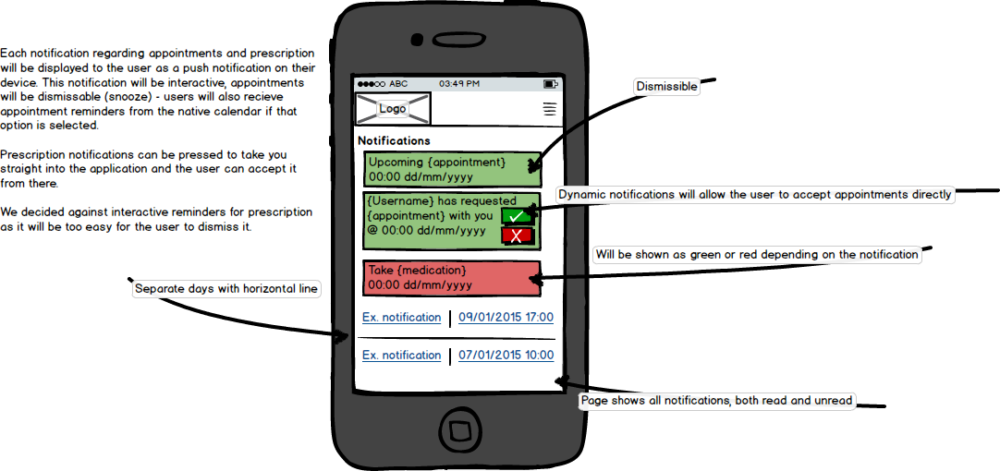Reminders are still dismissible and all notifications will show on this page.

## Web Application

### 3.2 Dynamic reminders

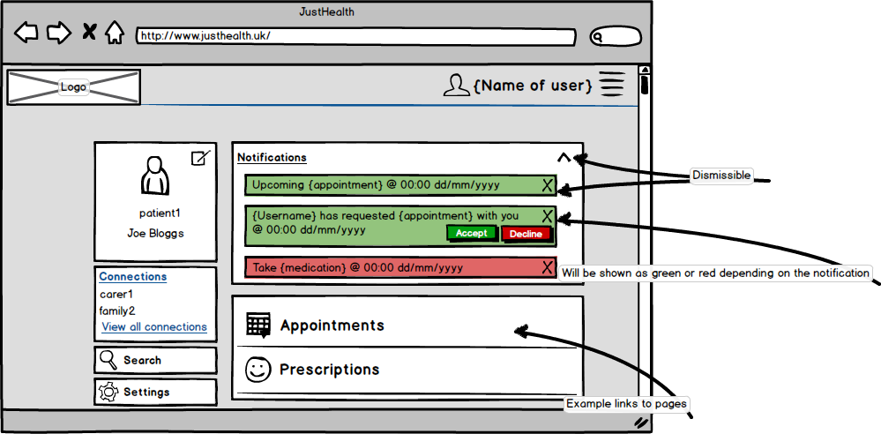The dismissible reminders on the dashboards will become dynamic for certain events, they will have options to either accept or decline requests from connections.

### 3.3 Patient/Carer correspondence

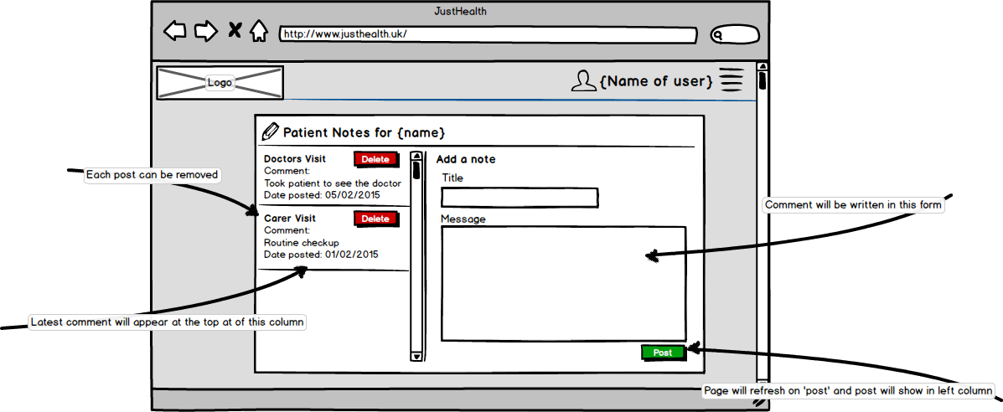Carers will have the option to record notes for their patients, in a further attempt to create a unique application for all needs within the care industry.

## 4.0 Admin Portal

We have decided to add the functionality of an information management portal. It is risky and unsecure to manually control account settings from directly within the database. Below are the designs for an administrative user interface, where they can:

* Edit account settings
* View and add new medication
* View and add new deactivation reasons
* View user statistics
* View JustHealth site statistics

### 4.1 Home page

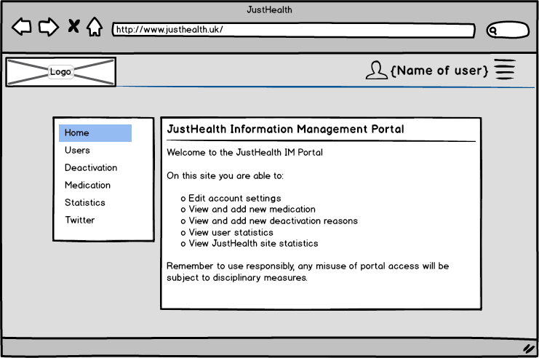

### 4.2 User account settings page

### 4.3 Deactivation settings

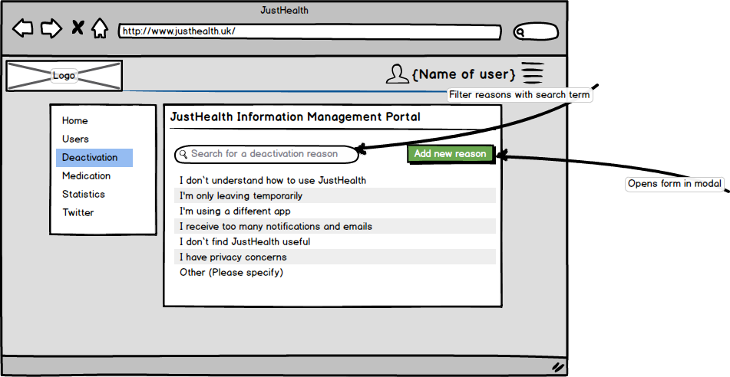This page is not for the admin to deactivate accounts, but rather to change the settings for users to deactivate their own accounts. User accounts can be locked, deactivated or deleted through the user settings page.

### 4.4 Medication settings

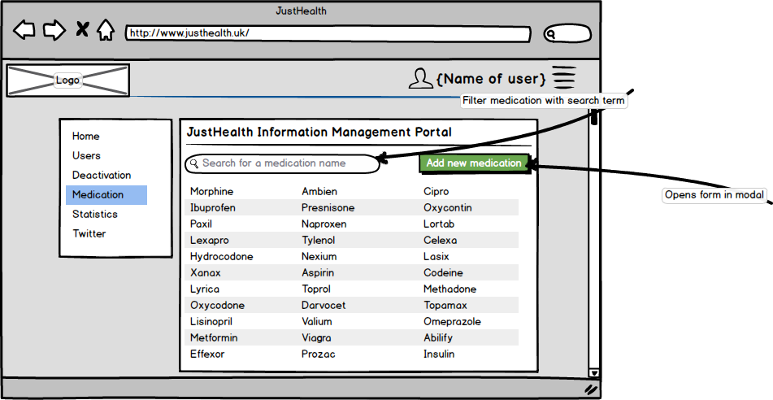This page will be to add new medication names (prescription drug names can currently only be selected from a dropdown list) this function will add the name to the list.

### 4.5 Application statistics

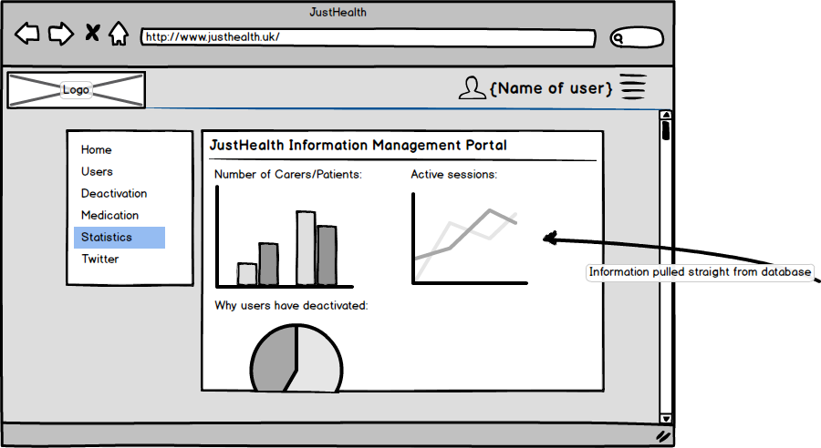This page will show statistics based on current database records and user activity

### JustHealth Twitter

# 5.0 Use cases:

## 5.1 Patient taking medication and carer notification

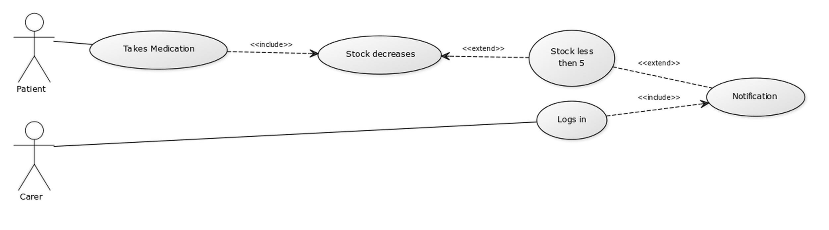

## 5.2 Search NHS Website

